**How to Install Twilio on to Heroku site**

Date: 17-JAN-2019

1. Go to your project folder in VS Code – inside Terminal – use bash. In this case it is:
   1. /c/Users/USWU32441/Dropbox/Ravi/Learning/Node.js/UdemyNodeJSCourse/TwilioSdkStarterNodeMaster/sdk-starter-node-master

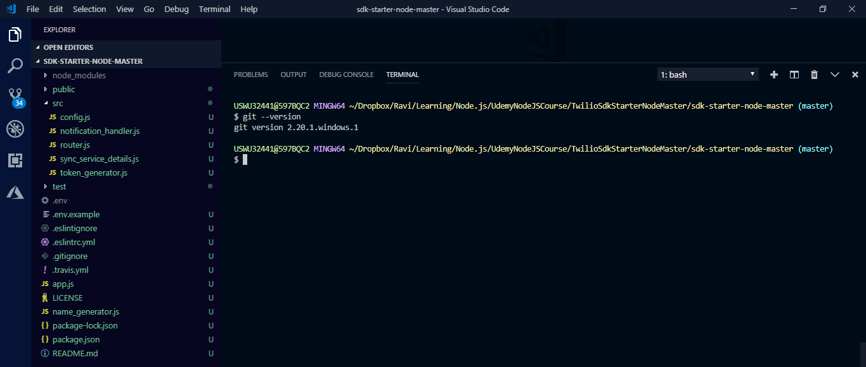

1. Check your git version
   1. git --version
2. Make this a git repository
   1. git init
3. Check git status
   1. git status

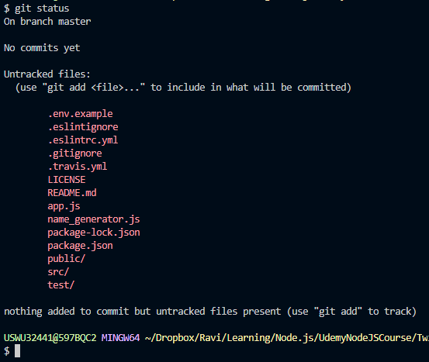

1. Add file to git
   1. git add .
2. Commit git
   1. git commit -m “Initial Twilio SDK check in”
3. Setup ssh keys – refer to manual
4. Make sure ssh keys are github are all connected – run the following command:
   1. ssh -T [git@github.com](mailto:git@github.com)
   2. Output should be:
      1. Hi krs68! You've successfully authenticated, but GitHub does not provide shell access.
      2. NOTE: for this to work had to install socat.exe from github an added following lines to ~/.ssh/config:

# Reference:

# https://makandracards.com/makandra/45758-capistrano-3-how-to-deploy-when-a-firewall-blocks-your-git-repo

host github.com ssh.github.com

User git

Hostname ssh.github.com

Port 443

ProxyCommand ~/socat/socat.exe - PROXY:www.wb.xerox.com:%h:%p,proxyport=8000

1. Go to github.com and create a new repository “twilioNodeJSSDK” then you will see the following page and you will need to execute the commands given.

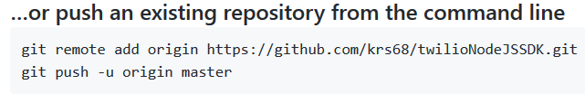

1. Once these are done, go back to github home page, you should see your repository
2. Create account on Heroku.com; and complete ssh key setup, refer to manual; make sure to download and install hiroku tool belt executable
3. Make sure Heroku is installed, use the following command:
   1. heroku --help
4. Login into Heroku using the command “heroku login” – this will open a browser and ask you to login and then you get back to prompt which looks like:

$ heroku login

heroku: Press any key to open up the browser to login or q to exit:

Logging in... done

Logged in as [rakasarla@yahoo.com](mailto:rakasarla@yahoo.com)

1. Push github code to Heroku:

$ heroku create

Creating app... done, ⬢ mighty-shelf-94819

https://mighty-shelf-94819.herokuapp.com/ | <https://git.heroku.com/mighty-shelf-94819.git>

$ git push heroku

Enumerating objects: 43, done.

Counting objects: 100% (43/43), done.

Delta compression using up to 2 threads

Compressing objects: 100% (40/40), done.

Writing objects: 100% (43/43), 71.95 KiB | 1.53 MiB/s, done.

.

.

.

.

remote: -----> Build succeeded!

remote: -----> Discovering process types

remote: Procfile declares types -> (none)

remote: Default types for buildpack -> web

remote:

remote: -----> Compressing...

remote: Done: 23.7M

remote: -----> Launching...

remote: Released v3

remote: https://mighty-shelf-94819.herokuapp.com/ deployed to Heroku

remote:

remote: Verifying deploy... done.

To https://git.heroku.com/mighty-shelf-94819.git

* [new branch] master -> master

1. Your environment variables are not set, if you try to access this URL <https://mighty-shelf-94819.herokuapp.com/>, you will get following error:

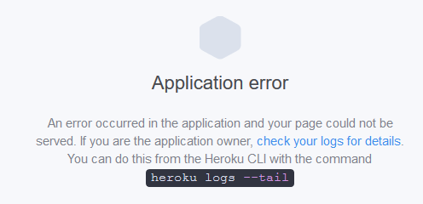

1. Go to Heroku and setup the environment variables:

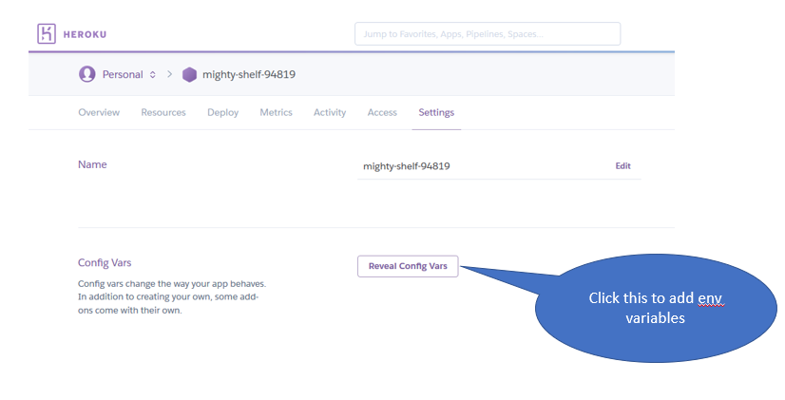

1. Restart your Web Apps, More button on top right and then “Restart all Dynos”
2. Now the page shows up:

